**PROJECT: Frank and Oak’s Style Plan**

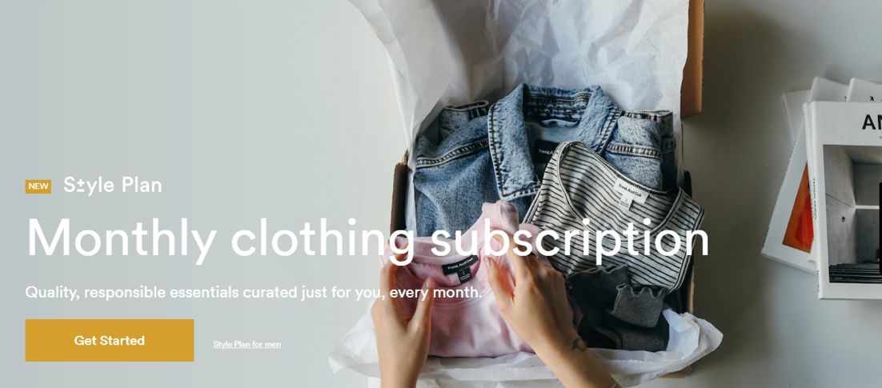

**Project Deliverable 1**

**Overview of the business scenario**

**Scope of our database**: End to end customer profiling and inventory matching for types of shirts.

**Business functionalities included in the scope of our database**:

* Frank and Oak are an online based clothing retailer. The businesses unique selling proposition is a monthly subscription that sends customers clothing items based on their unique preferences.
* One special consideration is that our database takes into account stylists
  + These individuals are assigned to customers based on the customer’s preference selections and thus are most adept to make fashion decisions.
  + The machine learning algorithm makes selections regarding the customer preferences and the stylists shortlist the selections to finalize the order.
* For the purposes of our database, **the only clothing item to be stored as inventory are shirts** for both male and females

Screenshots:

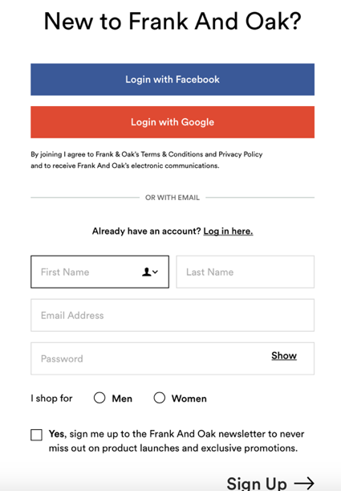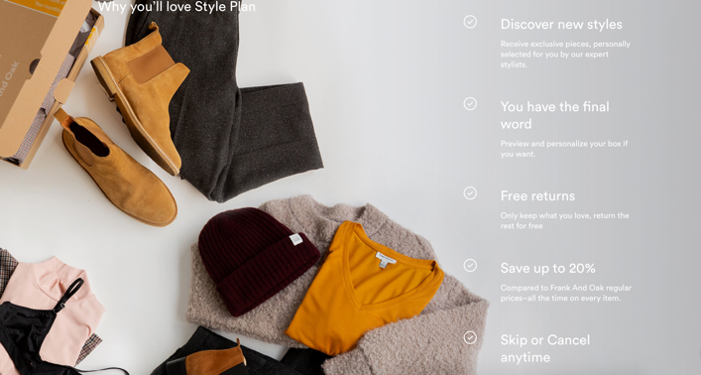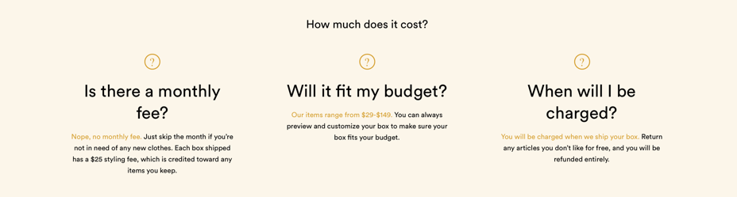

* Style Plan Sign Up:

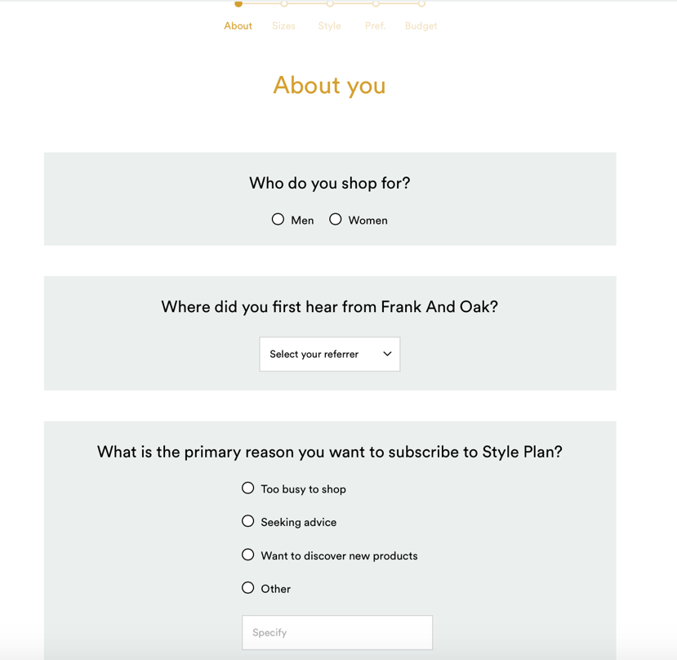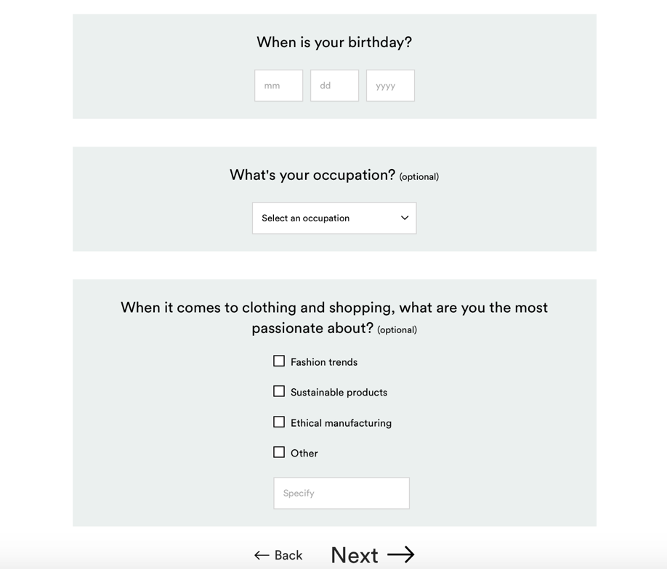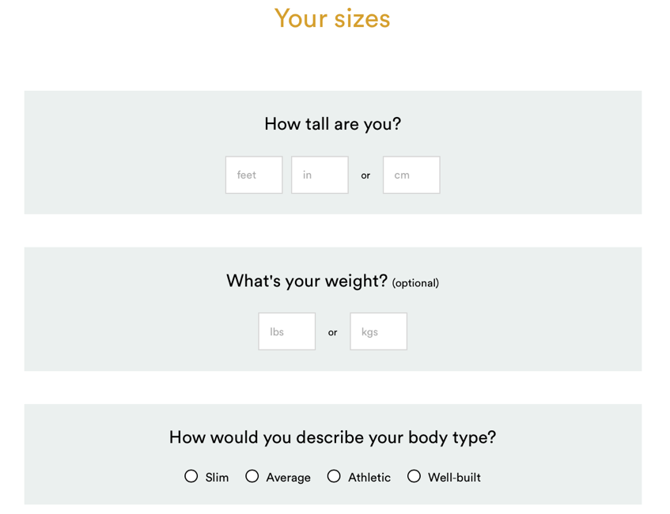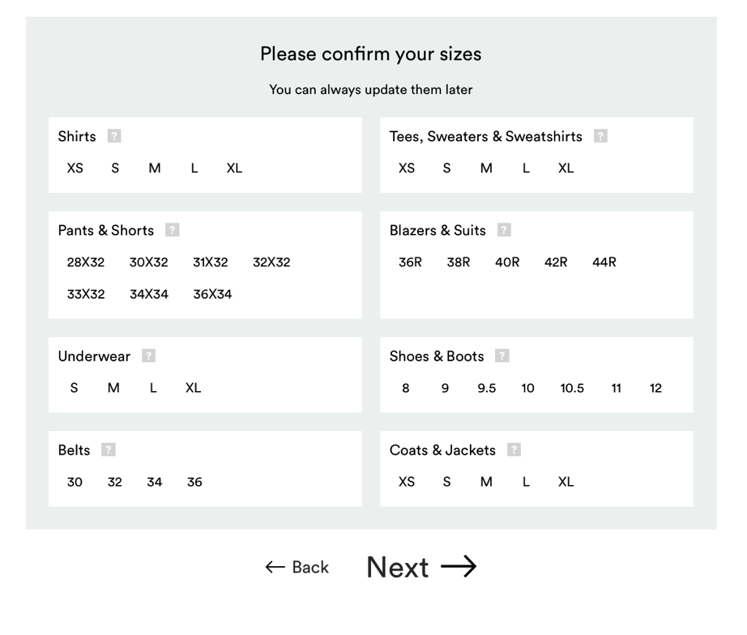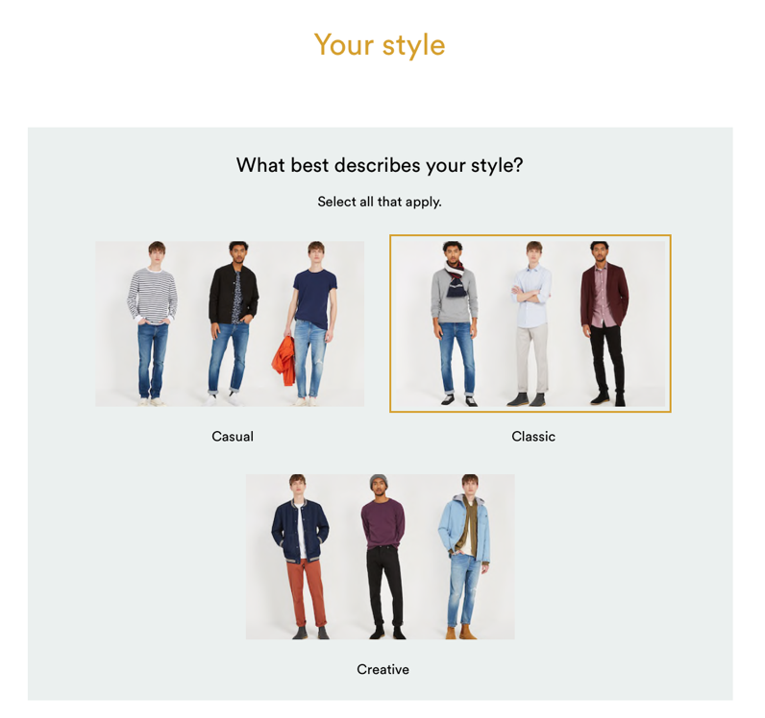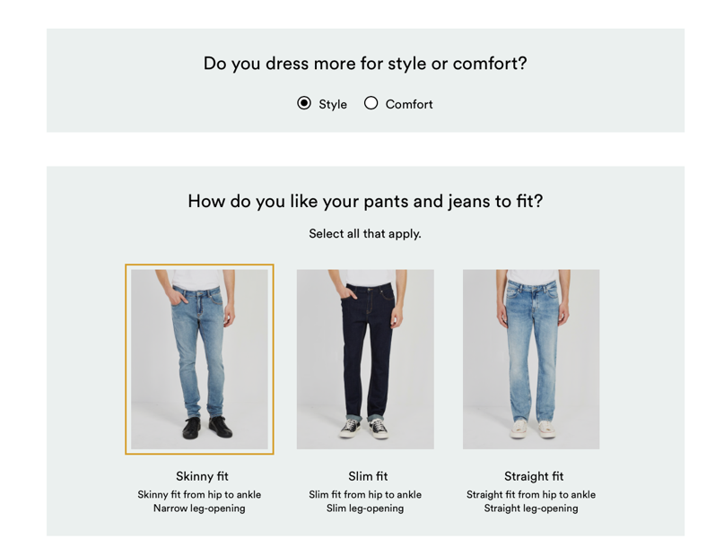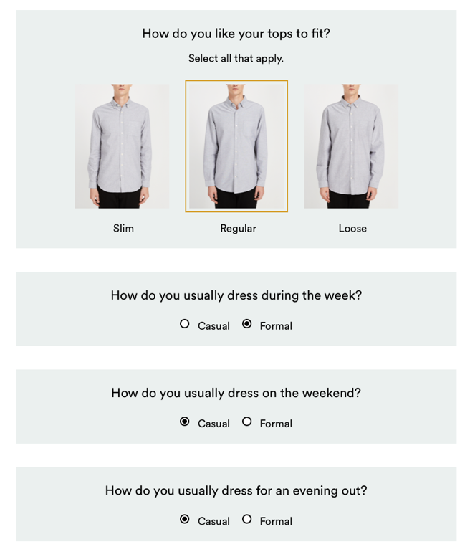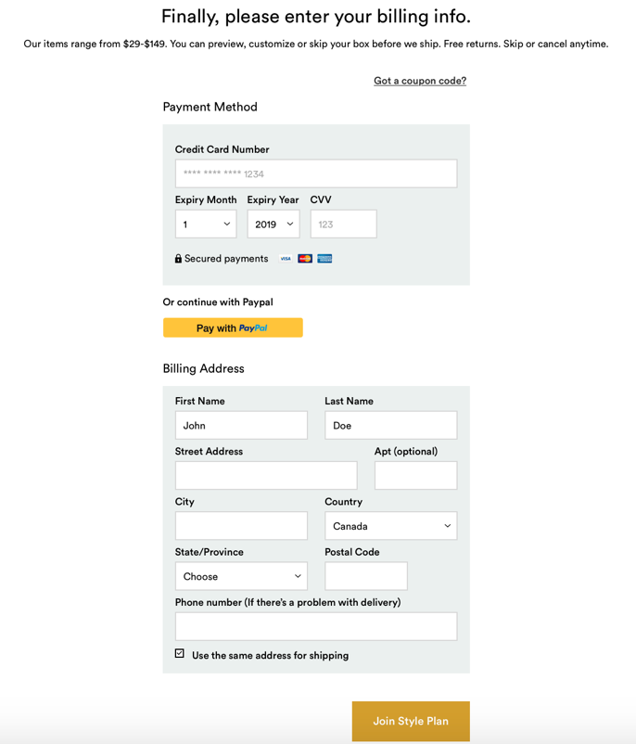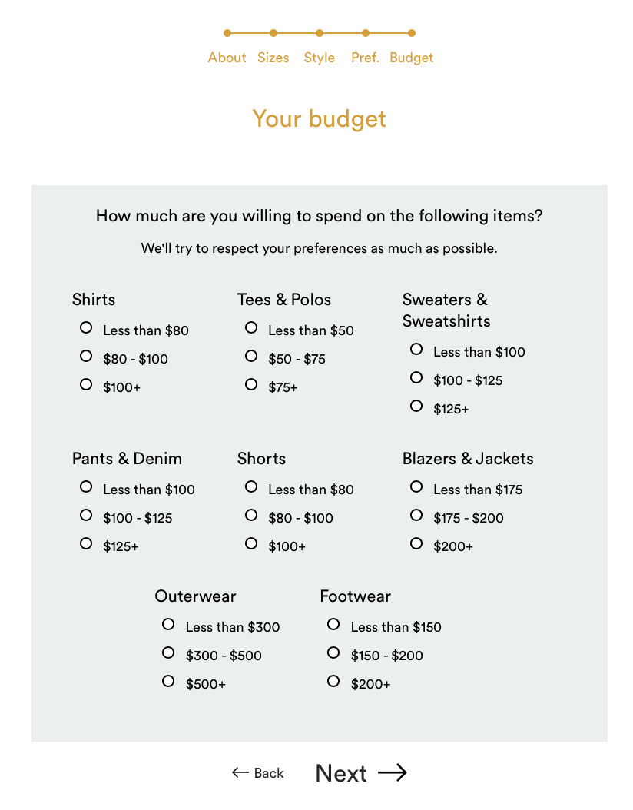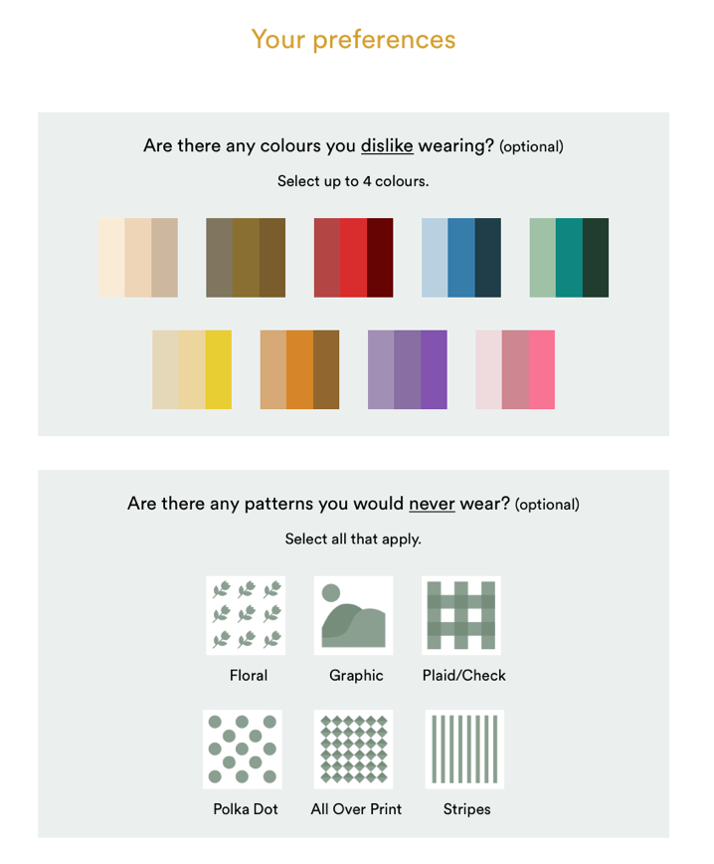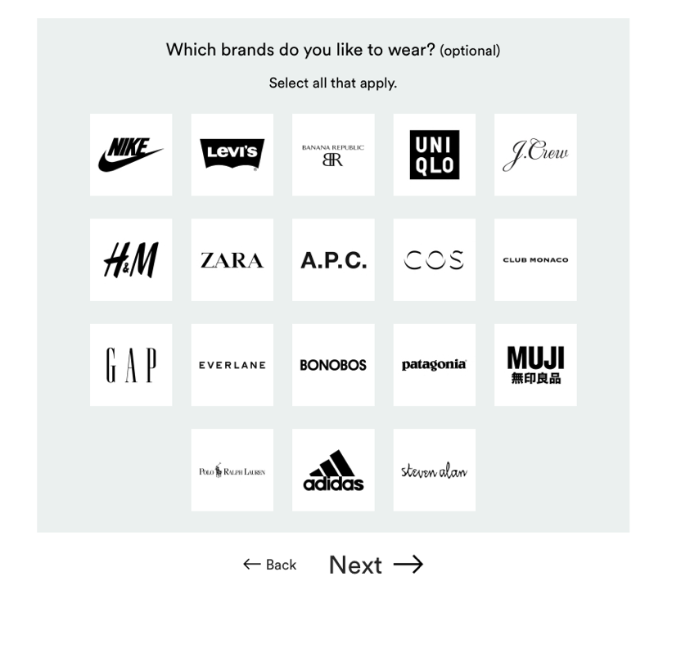

**Database design:**

Top-down approach

**Assumptions about our business:**

An algorithm using machine learning techniques are used to match the perfect outfit to each specific client.The assumption is that the table customer_pref_matching(explained later) will get automatically populated by the business rules and not by us.

Frank and Oaks only deals with shirts.

They have only one warehouse which also serves as the distribution center.

Payment is handled by Frank and Oaks and not third party security applications.

Only Credit Card accepted.

**Mission** **Statement**

The mission statement for Frank and Oak’s database system is to store and maintain data we received or generate from the monthly style plan and to supply information that helps us meet our dream to provide tailored shirts for each unique customer. The second purpose of the database system is to support our logistical needs and sales performance by maintaining, tracking and reporting our data; to help the management team make sounds decisions.

**Mission** **Objective**

To maintain (Enter, Update, Delete) data on customer

To maintain (Enter, Update, Delete) data on customer payment information

To maintain (Enter, Update, Delete) data on customer size

To maintain (Enter, Update, Delete) data on customer preferences

To maintain (Enter, Update, Delete) data on stylists

To maintain (Enter, Update, Delete) data on suppliers

To maintain (Enter, Update, Delete) data on shirt items

To maintain (Enter, Update, Delete) data on returned items

To maintain (Enter, Update, Delete) data on orders

To maintain (Enter, Update, Delete) data on invoices

To maintain (Enter, Update, Delete) data on shipment information

To perform searches on customer

To perform searches on customer preferences

To perform searches on customer size

To perform searches on stylists

To perform searches on shirts items

To perform searches on returned items

To perform searches on orders

To perform searches on invoices

To perform searches on shipment information

To track the status of customer preferences

To track the status of customer size

To track the status of shirts items

To track the status of orders

To track the status of invoices

To track the status of shipment information

To report on customer preferences

To report on shirts items

To report on returned items

To report on orders

To report on invoices

To report on shipment information

**ERD** (try to fit it on one page)

**Data Dictionary**

Description of Entities

|  |  |  |  |
| --- | --- | --- | --- |
| Entity name | Description | Aliases | Occurrence |
| Customer | It contains the user’s information. | Cust | Customer can have at least one preference, size, payment info and stylist.  Customer provide information to algorithm which will generate many results out of it.  Customer is placed for many orders. |
| Customer_preferences | It contains information regarding the users preferences in the clothing that he wears, i.e his favorite pattern, color etc. | Cust_pref | It is unique for every customer and for each preference there must be a customer. |
| Customer_payment_info | It contains the information regarding the type of payment method used by the user. | Cust_payment_info | It is unique for every customer and for each payment info there must be a customer. |
| Customer_Pref_Matching | This table stores the result of the frank and oaks algorithm through which they find out what type of clothing a particular user might like. | Cust_Pref_Matching | Each algorithm result will have at least one customer, shirt item and stylist. |
| Stylist | This tables stores the information of the stylist who chooses the cloth. | Styl | Each stylist can manage many stylist and at least one stylist is managed by other stylist. |
| Supplier | Stores the information of the supplier who would provide the clothing to frank and oaks. | Supp | A supplier provide many resources to many shirt items. |
| Shirt items | It stores the information regarding the shirt i.e its price, color, pattern etc. | S_tems | A shirt item gets resources from many stylist.  A shirt item can have many returned item at most and zero items at least.  Shirt item has many order at most . |
| Returned item | It stores the information of the items returned by the user. | R_item | Many items can be shipped from shipment info and at least one item from order would be there in returned items. |
| Shipment info | It stores the shipment information. | Ship_info | Shipment info can have many items from orders and at least one item from returned item. |
| Orders | It includes all the items that are been sent to the users. | Orders | Order would have at least one customers, customer_payment_info and stylist.  Order can have many shirt items and returned items. |
| Invoice | It includes the information of invoice, that is the bill of the items bought by the users. | Invoice | Invoice would be of at least one order and it can have a maximum of one order. |

Description of Attributes

|  |  |  |  |  |  |  |  |
| --- | --- | --- | --- | --- | --- | --- | --- |
| Entity Name | Attributes | Description | Data Type | Nulls | Multi-valued | Derived | Default |
| Customer | Customer_id | Unique ID for each customer | integer | No | No | No | None |
|  | First_name | First Name of Customer | 50 variable chars | No | No | No | None |
|  | Last_name | Last Name of Customer | 50 variable chars | No | No | No | None |
|  | age | Age of Customer | Int | No | No | No | None |
|  | gender | Gender of Customer  (M/F) | 10 Variable  chars | No | No | No | None |
|  | email | Email of Customer | 255  variable chars | No | No | No | None |
|  | contact_no | Phone Number of Customer | 50 variable chars | No | No | No | None |
|  | Street_adress | Address of Customer | 250  variable chars | No | No | No | None |
|  | city | City of Customer | 50 variable chars | No | No | No | None |
|  | state | State of Customer | 50 variable chars | No | No | No | None |
|  | country | Country of Customer | 50 variable chars | No | No | No | None |
|  | Customer_size | Customer size preference | 10 Varchar | No | No | No | None |
|  | {Height, Weight, Body_Type} | Customer height, weight and body type specification | Composite | No | Yes | No | None |
| Customer payment information | Payment_id | Payment ID given to Customer | small int | No | No | No | None |
|  | Customer_id | Unique Id of each Customer | integer | No | No | No | None |
|  | Payment_method | Visa, MasterCard, American Express | 25variable chars | No | No | No | None |
|  | Credit card number | Customer credit card number | int | No | No | No | None |
|  | Zip code | Customer Postal/Zip Code | 10  variable chars | No | No | No | None |
|  | Expiration date | Credit Card expiry Date | datetime | No | No | No | None |
|  | is authorized | Customer Credit Card Authorization | boolean | No | No | No | None |
| Customer preferences | Customer_id | Unique ID given to customer | integer | No | No | No | None |
|  | Order_pref | Preference number for order | 25 variable chars | No | No | No | None |
|  | Colours | Colors that Customers like | 15 variable chars | No | Yes | No | None |
|  | Pattern | Patterns that Customer likes | 15 variable chars | No | Yes | No | None |
|  | Fit | Customer fit | 15 variable chars | No | No | No | None |
|  | Preferred_stylist_id | ID of associated ID | integer | No | No | No | None |
|  | Note_to_stylist | Message from Customer to stylist | text | No | No | No | None |
| Customer_pref_mach | Result_id | Result ID given by Machine Learning Algorithm | integer | No | No | No | None |
|  | Customer_id | Unique ID given to Customer | integer | No | No | No | None |
|  | Item_id | Id given to each item | integer | No | No | No | None |
|  | Brand_match_score | Score given by algorithm on association of brand to customer preferences | Decimal(1,3) | No | No | No | None |
|  | Fit_score | Likelihood of fit based on Customer preferences | Decimal(1,3) | No | No | No | None |
|  | Colour_pref_score | Likelihood of color matching based on Customer preferences | Decimal(1,3) | No | No | No | None |
|  | Pattern_score | Likelihood of pattern matching based on Customer preferences | Decimal(1,3) | No | No | No | None |
|  | Stylist_id | Unique ID given to stylist | integer | No | No | No | None |
|  | Stylist note | Custom message from customer to stylist | text | No | Yes | No | None |
|  | Note to customer |  | text | No | No | No | None |
| Stylists | Stylist_id | Unique ID given to stylist | integer | No | No | No | None |
|  | First_name | First Name of Stylist | 50 variable chars | No | No | No | None |
|  | Last_name | Last Name of Stylist | 50 variable chars | No | No | No | None |
|  | Email | Email of stylist | 255 variable chars | No | No | No | None |
|  | Contact_no | Phone Number of stylists | 50 variable chars | No | No | No | None |
|  | Assigned customers id | Customers IDs matched to given stylist | integer | No | Yes | No | None |
|  | Rating | Performance Rating | decimal | No | No | No | None |
| Shirt_items | Item_id | Unique ID given to shirt inventory | integer | No | No | No | None |
|  | Supplier_id | Unique ID given to supplier | integer | No | No | No | None |
|  | type | Shirt Type | 15 variable chars | No | No | No | None |
|  | colour | Color of Shirt | 15 variable chars | No | No | No | None |
|  | quantity | Number of Shirts in total of a given type | integer | No | No | No | None |
|  | size | Different sizes available for that shirt | 15 variable chars | No | No | No | None |
|  | material | Make of the shirt | 15 variable chars | No | No | No | None |
|  | brand | Shirt Brand | 15 variable chars | No | No | No | None |
|  | Item_price | Price of Shirt | Decimal | No | No | No | None |
|  |  |  |  | No | No | No | None |
| Supplier | Supplier_id | Unique ID given to Supplier | integer | No | No | No | None |
|  | Supplier_name | Name of supplier | 100 variable chars | No | No | No | None |
|  | Supplier_address | Adress of Supplier | 250 variable chars | No | No | No | None |
|  | Supplier_phone | Supplier phone number | 50 variable chars | No | No | No | None |
| Orders | Order_id | Unique ID given to order | integer | No | No | No | None |
|  | Customer_id | Unique ID given to Customer | integer | No | No | No | None |
|  | Item_id | Unique ID given to shirt | int | No | Yes | No | None |
|  | Order_date | Date of order | datetime | No | No | No | None |
|  | Payment_id | Unique payment ID given to Customer | integer | No | No | No | None |
|  | Item_count | Number of items in order | integer | No | No | No | None |
|  | Shipment_id | Unique ID for shipment | integer | No | No | No | None |
|  | Stylist_id | Unique ID for stylist | Type | No | No | No | None |
|  | Order_total | Total Price of Order | decimal | No | No | No | None |
|  | status | Status of Package i.e shipped/packages etc.. | 15 variable chars | No | No | No | None |
|  | Shipping date | Estimated date of delivery | datetime | No | No | No | None |
| Invoice | Invoice_id | Unique ID given to invoice | integer | No | No | No | None |
|  | Order_id | Unique ID given to each Order | integer | No | No | No | None |
|  | Invoice_status | Represents the state an invoice is in as it moves from being created, to being sent to a client, to being paid in full | 10 variable chars | No | No | No | None |
|  | Invoice_date | Date of invoice | datetime | No | No | No | None |
|  | Tax_amount | Amount of Invoice in tax | decimal | No | No | Yes | None |
|  | Invoice_amount_due | Amount Due | decimal | No | No | No | None |
| Shipment_info | Shipment_id | Unique ID given to shipment | integer | No | No | No | None |
|  | Order_id | Unique ID given to Order | integer | No | No | No | None |
|  | carrier | Carrier Service | 50 variable chars | No | No | No | None |
|  | Shipping_date | Date of Shipment | datetime | No | No | No | None |
|  | Expected_delivery_date | Estimated Time of Arrival | datetime | No | No | No | None |
|  | Shipping_amount | Cost of Shipping | decimal | No | No | No | None |
| Returned_items | item_id | Unique ID given to item | Int | No | No | No | None |
|  | order_id | Unique ID given to order | Int | No | No | No | None |
|  | shipment_id | Unique ID given to shipment | Int | No | No | No | None |
|  | return_date | Date of Return of item | datetime | Yes | No | No | None |
|  | is_exchange | Whether or not item has been exchanged | boolean | No | No | No | FALSE |
|  | reason_for_return | Reason why item was returned | text | No | No | No | Not Specified |
|  | Other_feedback | Customer feedback on item | text | Yes | No | No | None |

Relational Schema :

Customer(customer_id,first_name,last_name,age,gender,email,contact_no,street_address,city,state,country)

* Primary Key: Customer_id

Customer_Payment_info(Payment_id,customer_id,Payment_method,Credit_card_number,zip_code,expiration_date,is_authoriz)

* Primary Key: Payment_id
* Foreign Key: customer_id references Customer

Customer_preferences

(customer_id, preference_id,order_pref,color_code,pattern_code,fit,pref_stylis_id,notes_id)

* Primary key: Customer_id,Preference_id

Customer_pattern

Customer_PAttern(cutomer_id, pattern_code)

* Primary key: cutomer_id, pattern_code

Customer_color

(color_code, customer_id)

Primary key

* color_code, customer_id

Foreign keys

* color_code, customer_id

Colour(color_code,color_name)

* Primary Key: Colour_code

Pattern(Pattern_code, Pattern)

* Primary Key: Pattern_code,Pattern
* Foreign Key: Pattern_code references Customer_Preferences

Customer_size(customer_id,height, weight,body_type)

* Primary Key: customer_id

Customer_preference_match(Resultid, Customer_id,item_id, brand_match_score, fit_score, colour_pref_score,pattern_score,stylist_id,stylist_note,note_to_customer)

* Primary Key: Resultid
* Foreign Key: Customer_id references Customers
* Foreign Key: stylist_id references Stylists

Stylists(Stylistid,First_name,Last_name,Email,Contact_no,Assigned_customer_prefid, rating)

* Primary Key: Stylistid
* Foreign Key: Assigned_customer_prefid references Customer_preference_match(Customer_id,Order_pref)

Shirt_Items(Item_id,Supplier_id,type,colour,quantity,size,material,brand,item_price)

* Primary Key: Item_id

Supplier(Supplier_id,Supplied_name,supplied_address,supplie_photos)

* Primary Key: Supplier_id

Supplier_Shirt_items(Item_id,Supplier_id)

* Primary key: Item_id,Supplier_id

Orders(Order_id,Customer_id,order_date,payment_id,item_count,shipment_id,stylist_id,order_total,status,shipping_date)

* Primary Key: Order_id
* Foreign Key: Customer_id references Customers
* Foreign Key: Payment_id references Customer_payment_info
* Foeign Key: Stylid_id references Stylist

Orders_Shirt_items(Order_id,Itemd_id)

* Primary Key: Order_id,Itemd_id

Returned_items

(Item_id,Order_id,shipment_id,return_date,is_exchange,reason_for_return,other_feedback)

* Primary key: Item_id,Order_id
* Foreign key: Order_id references Orders
* Foreign key: Item_id references Shirt_items

Shipment_info(Shipment_id, Order_id,carrier,shipping_date,expected_delivery_date,shipping_amount,returned_id)

* Primary Key: Shipment_id
* Foreign Key: Order_id References Orders
* Foreign Key: returned_id References Returned_items(Item_id, Order_id)

Invoice(Invoice_id, Order_id,Invoice_status,Invoice_date,tax_amount,Invoice_amount_due)

* Primary Key: Invoice_id
* Foreign Key: Order_id References Orders